CARbon Airborne Flux Experiment

CARAFE Flight Reports

CARAFE Science Team

September, 2016

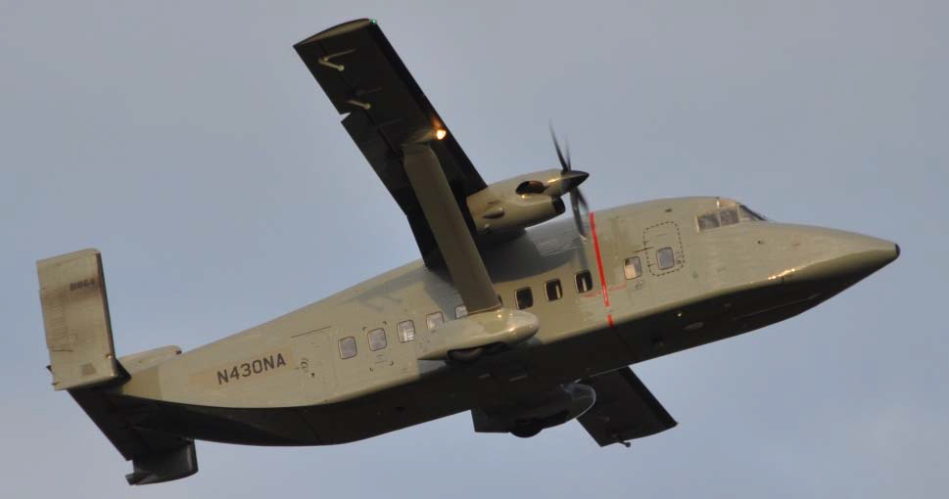

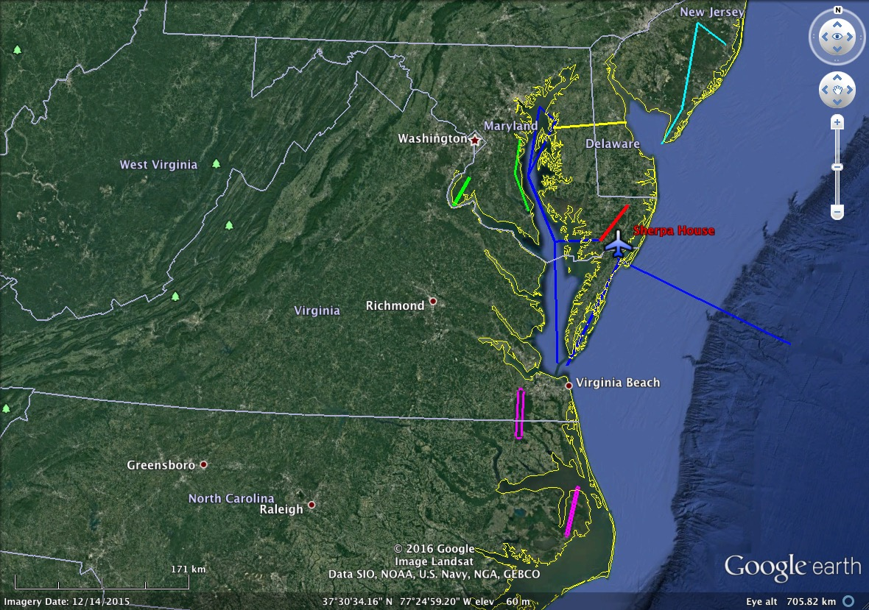
CARAFE Science Flight Report
2016-09-07
Test Flight #1
Pilots: R. Rogers, A. Barringer
Science Crew: R. Kawa, G. Wolfe, J. Barrick, J. Digangi
Reporting: R. Kawa
Objectives: Test instrument systems performance. Perform air motion calibration maneuvers. Characterize variations of mean fields and fluxes for GHGs, water, and heat at different altitudes over relatively uniform forested region.
Summary:
Flight from WFF started with a photogrammetry survey of Assateague Seashore beach erosion following former tropical storm Hermine passage over the previous weekend. Beach legs at 1000 to 1500 ft. Set of air motion calibration maneuvers (speed, yaw, reverse heading) was performed at 6500 ft. Flux legs over Pocomoke were flown back and forth at 3 altitudes in PBL (3500, 1500, 500 ft). Vertical profile to 9500 ft followed with additional set of speed variation and pitch maneuvers. Flight duration about 4 hours.

Instrument systems and flight procedures performed successfully. One tall tower and other lower ones were noted near the flight line, which may require some path adjustments. Speed maneuvers at 9500 ft clearly more stable than those at 6500, which was close to BL top over land. MBL appeared to be several hundred or more feet lower. Mostly clear with scattered mid-level clouds and higher thin cover. Seemingly persistent positive gradient of CO2 and CH4 toward SW end of BL legs.

Rawinsonde special sounding at 18Z flown from WFF.

Instruments:
LGR/Picarro/PAR – instruments performed normally. Air supply pumps overheated several times and pumping cut out for several seconds. Picarro (slow measurements) unaffected. PAR sensor worked well, needing only a minor gain adjust for full data. LGR recording system showed occasional 0 blips on CO2 channel, which will be obviated with adjusted sampling speed in future.

DLH – Got good data throughout. Found apparently excessive humidity in laser housing, but measurements only minimally affected.

BFVNI – Visible and multispectral (Micasense) cameras acquired images normally. FLIR focus was set improperly so no data there; fixed for future flights.

TAMMS – Good data throughout. Cal maneuvers appear successful. Applanix data looks normal.

NASDAT – Data recorded properly. Had some complications downloading data from USB drive postflight, but managed without losing anything. Noted occasional drop-outs of POS-AV data recording to NASDAT, but no unrecoverable loss. Also, only 2 of 4 Iridium modems working, later attributed to damaged cable.

Event Times (approximate):
15:52 POS-AV logging start
16:10 Power transition
16:25:18 Takeoff
16:35 to 17:17 Beach survey legs
17:17 to 17:25 Climb to 6500 ft
17:27 to 17:42 Speed variations at 6500 ft
17:43 Yaw maneuvers
17:45 to 17:59 Reverse heading 320/140 deg
17:59 to 18:07 Descend to Pocomoke NE waypoint
18:07 to 19:18 Flux legs at 3500, 1500, 500 ft
19:18 to 19:28 Profile to 9500 ft
19:30 to 19:42 Speed variations at 9500
19:42 - 19:44 Pitch maneuver
19:26 Pull BFVNI breaker
19:58:54 Landing
20:00+ Brief loss of power on transition to external

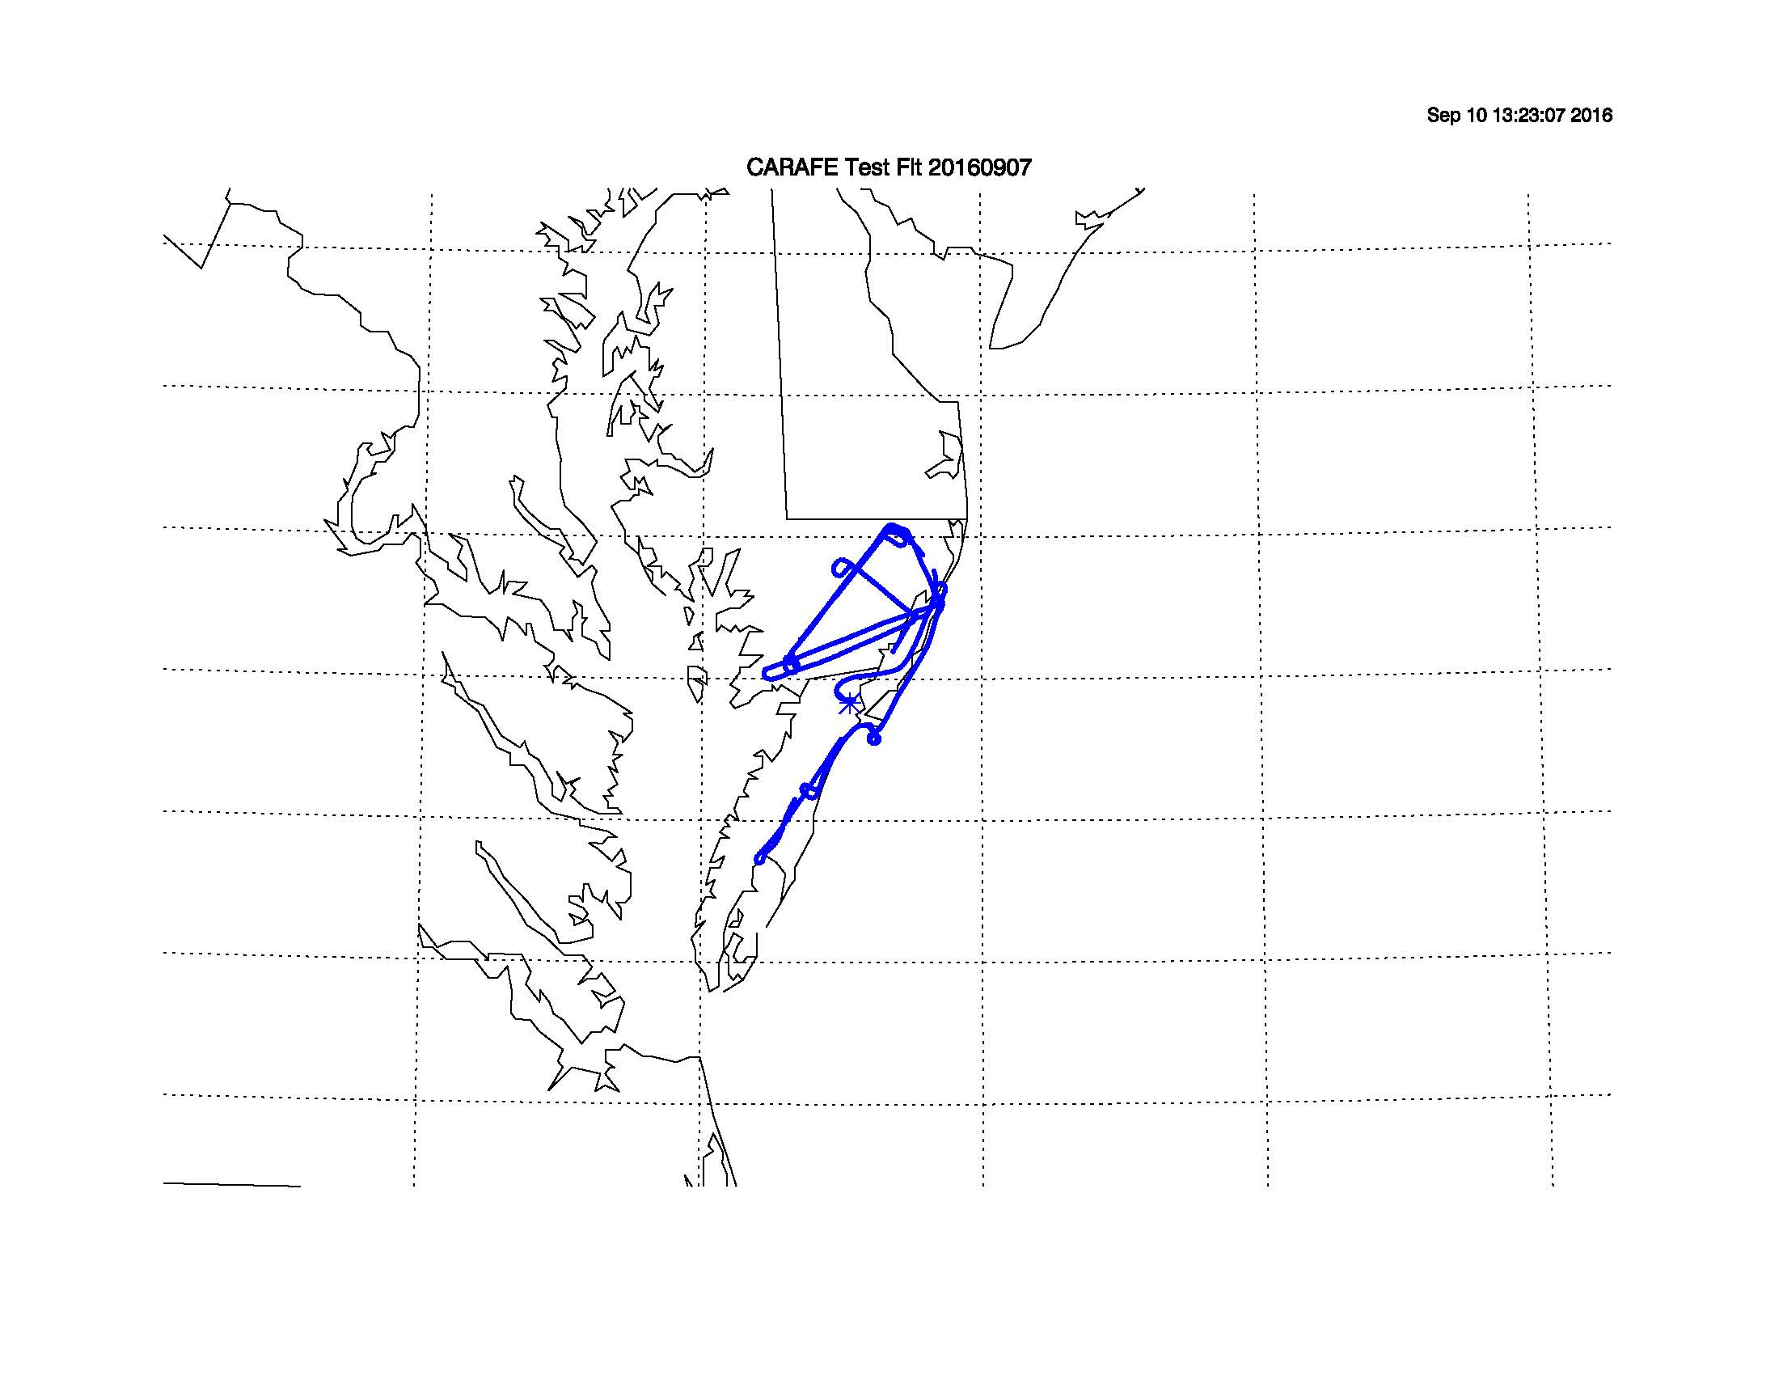

CARAFE Science Flight Report
2016-09-09
Science Flight #1 Pocomoke Forest
Pilots: A. Barringer, R. Rogers
Science Crew: R. Kawa, G. Wolfe, J. Digangi
Reporting: R. Kawa

Objectives: Verify instrument systems performance. Perform air motion calibration maneuvers as needed. Adapt flight leg altitudes to observed boundary layer height. Obtain baseline, midday early-month GHG, water, and heat fluxes over relatively uniform forested region. Characterize variations of mean fields, flux divergence, and surface flux from different altitudes in PBL.

Summary:
Flight was composed of sets of flux legs over Pocomoke sandwiched around a profile to 7500 feet and maneuvers. Set of air motion calibration maneuvers (speed, reverse heading, yaw, pitch) was performed at 7500 ft. Flux legs over Pocomoke were flown back and forth at 3 altitudes (3500, 1500, 500, 500 ft) in first set and 1500, 500, 500 ft in second set. Flight duration about 4 hours.

Instrument systems and flight procedures performed successfully. Installation of added cooling fan to LGR pumps prevented overheating. Boundary layer relatively shallow, apparently near 1500 ft leg in the morning; somewhat higher later in the day. 3500 ft legs likely above mixed layer. Mostly cloudy with partly translucent mid-level cloud cover above at least 10k ft and pervasive haze. Shadows often visible on the ground. Seemingly persistent positive gradient of CO2 and CH4 toward SW end of BL legs occasionally apparently discreet plumes usually correlated with water. Quite warm inside and outside cabin throughout flight at low altitudes.

Rawinsonde special sounding at 18Z flown from WFF.

Instruments:
LGR/Picarro/PAR – instruments performed normally. Air supply pumps ran initially at 80% capacity increased to 100% after profile. No difference to measured pump skin temperature. No overheating cutoffs. PAR sensor and Picarro worked well. No anomalies on LGR recording system.

DLH – Got good data throughout. Improved sealing of laser housing greatly reduced excessive humidity in flight. Negligible effect on measurements.

BFVNI – Visible, FLIR, and multispectral (Micasense) cameras acquired images normally.

TAMMS – Good data throughout. Cal maneuvers appear successful. Applanix data looks normal.

NASDAT – Data recorded properly. Again noted occasional drop-outs of POS-AV data recording to NASDAT, but no unrecoverable loss. 2 of 4 Iridium modems working. Non working ones attributed to damaged cables, which will be fixed for next flight.

Event Times (approximate):
14:11 POS-AV logging start
15:06 Engines on
15:09 Power transition
15:23:05 Takeoff, transit to Pocomoke NE
15:36 to 17:23 Flux legs at 3500, 1500, 500, 500 ft
17:23 to 17:32 Climb to 7500 ft
17:32 - 17:48 Speed variations 120, 130, 140, 150? kts
17:50 Reverse heading
17:58:50 Yaw maneuvers
18:00 Pitch
18:03 to 18:08 Descend to Pocomoke NE
18:12 to 19:12 Flux legs at 1500, 500
19:12 Transit to WFF
19:20:05 Landing
19:25 Transition to external power, uninterrupted
19:41 POS-AV stop logging and shut down

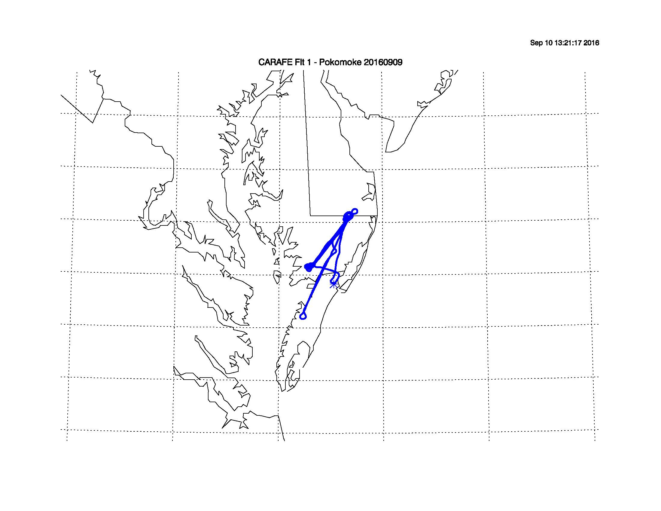

CARAFE Science Flight Report
2016-09-12
Science Flight #2 Ag Flux
Pilots: R. Rogers, A. Barringer
Science Crew: R. Kawa, G. Wolfe, J. Digangi
Reporting: R. Kawa

Objectives: Obtain GHG, water, and heat fluxes over relatively flat, extensive agricultural region across northern DelMarVa Peninsula. Characterize variations of surface flux with surface type and condition. Compare airborne flux distributions with those from flux towers at USDA Choptank and U DE St. Jones Reserve. The latter provides CH4 and CO2 tower fluxes and a test sample of flux over tidal marsh.
http://ameriflux-data.lbl.gov:8080/SitePages/siteInfo.aspx?US-StJ
http://www.ars.usda.gov/research/projects/projects.htm?accn_no=425859

Summary:
Flight featured sets of flux legs across the Peninsula at 1500 and 500 ft. Profiles to 5500 and 7500 ft were performed before and after the legs, respectively. Legs appeared to pass nearly overhead the St James and Choptank sites. Outbound transit flight also took data at 1500 and 500 ft approaching Chester River point. Return transit took data at 500 ft including a pass over Pocomoke from NE to SW. Flight duration about 4 hours.

Weather was nearly perfect for measuring turbulent fluxes from/to the surface. Sky was clear and sunny with a few scattered high clouds. Some haze near the BL top. Early leg at 1500 ft was near entrainment layer, but later 1500 ft leg was quite turbulent and well below scattered small cloud bases. Surface was a mosaic of fields, woods, and small settlements. Fields were in various stages of growth from harvested to standing brown to bright green to actively irrigated. Quite warm inside and outside cabin throughout flight at low altitudes. Noticeably less turbulent over water on either end of legs.

Instrument systems and flight procedures performed smoothly. There seemed to be a persistently strong positive CH4 gradient (delta CH4 ~ 30 ppv) over the Chester River toward W end of the BL legs. No apparent enhancement on E end over salt marsh. We should consider looking for CH4 flux from fresh water surface and marshlands.

Rawinsonde special sounding at 18Z flown from WFF.

Instruments:
LGR/Picarro/PAR – instruments performed normally. Air supply pumps ran at 100% capacity with external cooling fan. Measured pump skin temperature about 40 C. No overheating cutoffs. PAR sensor and Picarro worked well. No anomalies on LGR recording system.

DLH – Got good data throughout.

BFVNI – Visible, FLIR, and multispectral (Micasense) cameras acquired images normally.

TAMMS – Good data throughout. Applanix data looks normal.

NASDAT – Data recorded properly. Still had occasional drop-outs of POS-AV data recording to NASDAT, but no unrecoverable loss. 2 of 4 Iridium modems working; still working on fix.

Event Times (approximate):
14:22 POS-AV logging start
14:45 Engines on, power interrupted (cockpit switch)
14:53 Power transition, back on, re-warm
15:06:25 Takeoff
15:09 to 15:34 Transit to Salisbury and Chester
15:34 to 15:45 Profile near Chester
15:48 to 18:16 Flux legs at 1500 ft, 500 x 5, 1500 x 2
18:16 Spiral ascent to 7500 ft over center of track
18:23 Descend to 500 ft
18:30 – 18:46 Transit to Pocomoke at 500 ft
18:48 – 18:55 Pocomoke leg NE to SW at 500 ft
18:55 Transit to WFF
19:03:05 Landing
19:08 Transition to external power, uninterrupted
19:20 POS-AV stop logging and shut down

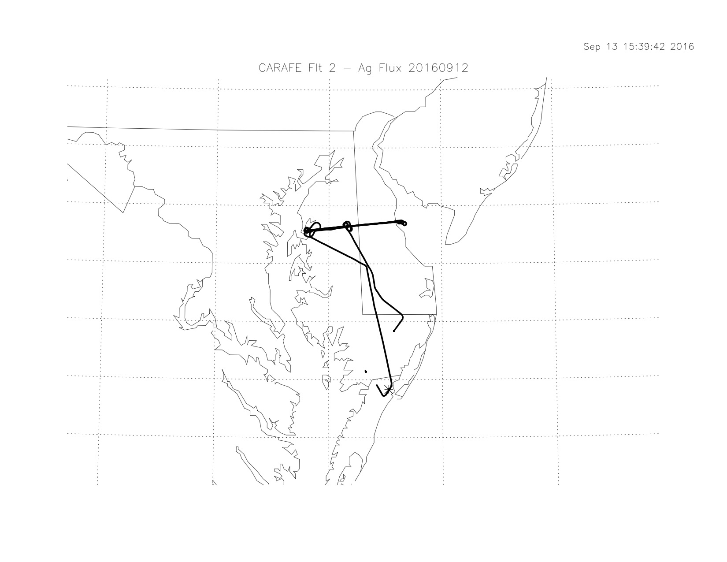

CARAFE Science Flight Report
2016-09-14
Science Flight #3 NJ Pine Barrens
Pilots: A. Barringer, R. Rogers
Science Crew: R. Kawa, T. Hanisco, G. Wolfe, J. Digangi, C. Sorenson
Reporting: R. Kawa

Objectives: Measure GHG, water, and heat fluxes over the New Jersey Pine Barrens, the largest continuous forested landscape on the Northeastern coastal plain. Characterize variations of surface flux with forest type, disturbance state, and surface conditions. Compare airborne flux distributions with those from Ameriflux tower measurements at Silas Little and Cedar Bridge sites.
http://ameriflux-data.lbl.gov:8080/SitePages/siteInfo.aspx?US-Slt
http://ameriflux-data.lbl.gov:8080/SitePages/siteInfo.aspx?US-Ced

Summary:
Flight featured 3 round-trip sets of flux legs across the Pine Barrens at 1500 and 500 ft. A profile to 7000 ft was performed after the legs over the southernmost end of NJ. Legs appeared to pass nearly overhead the Cedar Bridge site and near to the Silas Little sites. Outbound transit flight also took data at 1500 ft inland from coast and across Delaware Bay. Flight duration about 4.3 hours.

Weather was excellent for measuring turbulent fluxes from/to the surface. Sky was clear and bright with a thin haze early on. Scattered clouds developed above flight level later in the day mostly to the east. All legs seemed to have good turbulence including those at 1500 ft. Surface was mostly a wide area of nearly unbroken woods, with some settlements and roads near the middle of the N-S track. Not much agriculture at all. Forest was generally uniform height, although sparser with pines more prevalent than in DelMarVa. Everything seemed quite dry from the air. Quite warm inside and outside cabin throughout flight at low altitudes.

We had a serendipitous, repeated encounter with a fairly intense CH4 plume from an active landfill near the S end of the flight legs (NJ Mid waypoint). CH4 up to >2.6 ppmv and seemingly filling the whole BL locally (500 and 1500 ft). Cape May County Mua Secure Landfill likely (https://ghgdata.epa.gov/ghgp/service/facilityDetail/2014?id=1004200&ds=E&et=undefined&popup=true). We also passed by another landfill on the E-W leg but this one had only small CH4 enhancement on downwind side (Ocean County Landfill?).

Instrument systems and flight procedures performed well. A failed radio on the plane caused momentary concern and holding pattern S of McGuire AFB on the first leg, but it was soon revived.

Rawinsonde special sounding at 18Z flown from WFF.

Instruments:
LGR/Picarro/PAR – instruments performed normally. Air supply pumps ran at 100% capacity with external cooling fan. Measured pump skin temperature about 40 C. No overheating cutoffs. PAR sensor and Picarro worked well.

DLH – Got good data throughout.

BFVNI – Visible, FLIR, and multispectral (Micasense) cameras acquired images normally.

TAMMS – Good data throughout. Applanix data looks normal.

NASDAT – Data recorded properly. Still had occasional drop-outs of POS-AV data recording to NASDAT, but no unrecoverable loss. Problem appears to be in Applanix output stream. Also noted possible problem with NASDAT calculated wind direction; to be fixed in post processing.

Event Times (approximate):
14:44 Engines on, power interrupted twice before switch over
14:47 Power transition, back on, re-warm
15:07:01 Takeoff
15:09 to 15:34 Transit to NJ at 1500 ft
15:43 to 18:46 Flux legs (mirror 7 shape) at 1500, 500 x 4, 1500 ft
18:46 En route ascent to 7000 ft at S of track (NJ mid waypoint)
19:00 Descend toward 3500 ft
19:02 Transit to WFF
19:17:20 Landing
19:21 Transition to external power, uninterrupted
19:22 Engines off

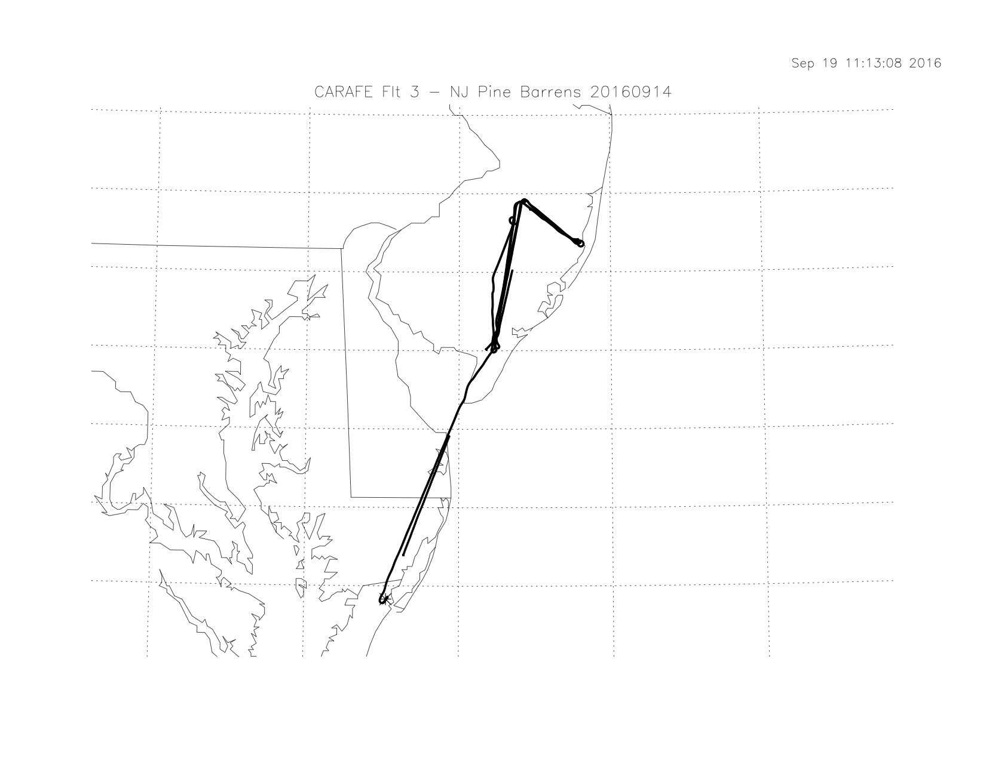
CARAFE Science Flight Report
2016-09-16
Science Flight #4 Pocomoke Forest Revisited
Pilots: R. Rogers, A. Barringer
Science Crew: P. Newman, T. Hanisco, J. Digangi, H. Maring, B. Lefer
Reporting: P. Newman, R. Kawa

Objectives: Measure GHG, water, and heat fluxes over Pocomoke again to test statistical repeatability of fluxes and possibly response to varying sky cover. Characterize variations of mean fields, flux divergence, and surface flux across the landscape from different altitudes in PBL. Obtain another set of speed variation calibration maneuvers.

Summary:
We basically flew the SW-NE track across the Pocomoke Forest all day. We started with a jump up to 6,500 feet and spiraled down to 1st way point. Boundary layer top at 3,000-3,400 feet. There was a scattered cloud layer that was only a couple of hundred feet deep at this altitude all day long. We did our 1st leg at 2200, followed by 3 legs at 1400. We then did 4 legs at 500 feet, 2 more at 2500, 2 at 1500, and finally 3 at 500 feet - a total of 15 SW-NE legs over the course of the day. Successive legs were offset by about 1 mile horizontally to cover a larger set of surface elements. We did a jump up to 6,500 feet on our final leg back to the SW waypoint while doing some speed variations enroute. Speed variations maneuvers were performed in smooth air at 6500 ft at 120, 130, 140, 150 kts for 2 min. each. We then spiraled down at that point and returned to base. Flight duration about 4 hours.

Everything worked well, and the plane was fairly cool. The surface winds were good, but from the NE. Not a lot of heating, so most of the turbulence was dynamical. There was light chop all day long below the BL top, but the air was quite smooth at 6,500 feet. Scattered cloud at 3,000-3,400 feet. Boundary layer ~3200 feet.

Rawinsonde special sounding at 18Z flown from WFF.

Instruments:
LGR/Picarro/PAR – instruments performed normally. Air supply pumps ran at 100% capacity with external cooling fan. No overheating. PAR sensor and Picarro worked well.

DLH – Got good data throughout.

BFVNI – Visible, FLIR, and multispectral (Micasense) cameras acquired images normally.

TAMMS – Good data throughout. Applanix data looks normal.

NASDAT – Data recorded properly. Still had occasional drop-outs of POS-AV data recording to NASDAT, but no unrecoverable loss. Problem appears to be in Applanix output stream. Also noted possible problem with NASDAT calculated wind direction; to be fixed in post processing.

Event Times (approximate):
15:17 Taxi
15:21 Takeoff
15:21- 15:37 Profile to 6500 and descent
15:37 to 18:44 Flux legs at a variety of altitudes from 500 to 2500 ft
18:44 Ascent to 6500 ft along track
18:44 to 19:00 Speed variation maneuvers at 120, 130, 140, 150 kts
19:10 Landing

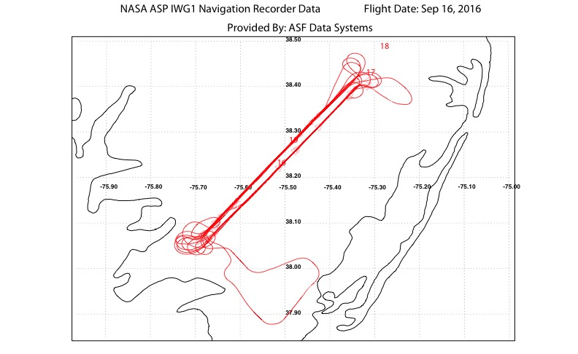

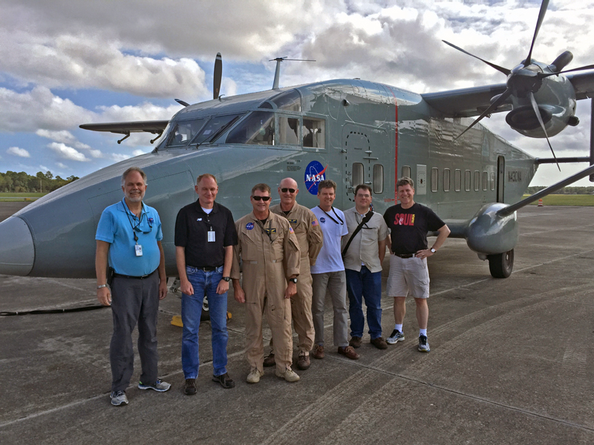

CARAFE Science Flight Report
2016-09-22
Science Flight #5 MD Tall Trees
Pilots: R. Rogers, A. Barringer
Science Crew: R. Kawa, P. Newman, G. Wolfe, J. Digangi,
Reporting: R. Kawa

Objectives: Measure GHG, water, and heat fluxes over tallest trees in MD with large fractional forest coverage according to UMD lidar surveys. Characterize variations of surface flux with forest height, type, and surface conditions. Prince Frederick legs will also test flux calculations in slightly more complex terrain. Compare airborne flux distributions with those from surface measurements at Smithsonian Environmental Research Center. The latter will provide a test sample of flux over tidal wetlands.
http://www.serc.si.edu/gcrew/index.aspx

Summary:

IFR takeoff and ferry to Easton then transit to PrinceFredN waypoint. Relatively long back and forth legs over Prince Frederick forest area at 2 altitudes in PBL. Passed over SERC on N end. Surface was mix of mostly forest, fields, and small settlements; more solid forest to S end. Modestly rolling terrain. Transit over to adjusted CharlesNE point moved S to avoid restricted area. Did flux run S at 1500 then dropped to 500 for multiple 5-6 minutes racetrack legs over forest on 3 tracks spaced 1-mi apart. Thick solid forest with occasional dwellings. Varying canopy height and structure. Turns at S end over Potomac appeared to have enhanced CH4 and maybe CO2. Vertical profile near CharlesNE enroute toward PrinceFredS. Dropped down and ran one last flux leg up PrinceFred at 500 ft, climbed to 5000 and returned to base. Duration 4 hours.

Thick low clouds at WFF gave way to scattered mid level and high thin overcast to N. Clear to mostly hazy sunshine over flux legs. Not much wind in the trees. Decent turbulence at all altitudes below about 2000’ especially at 500. Scattered clouds with bases at about 3,400 feet. Boundary layer ~3500 feet had no distinct cap in T or H2O; some Co2 gradient. Possibly several layers. Everything worked well, and the plane was fairly cool.

Rawinsonde special sounding at 18Z flown from WFF.

Instruments:
LGR/Picarro/PAR – Picarro instrument failed on off-day calibration test; bad computer power supply. Replacement part not delivered early enough, so LaRC/AVOCET Picarro from C-130 swapped into rack. Instrument appeared to run well. Vacuum pumps ran fine at 100% capacity with external cooling fan. LGR instruments and PAR sensor performed well.

DLH – Got good data throughout.

BFVNI – Visible, FLIR, and multispectral (Micasense) cameras apparently acquired images normally.

TAMMS – Good data throughout. Applanix data looks normal.

NASDAT – Data recorded properly. Again noted possible problem with NASDAT calculated wind speed; to be fixed in post processing. Used new UDP data plotting routine in flight and it worked well.

Event Times (approximate):
15:41 Engine start
15:44 Power switch
15:50 Taxi
15:58:20 Takeoff
15:59 Ascend to 5000 en route to Easton
16:23 Descend to 1500 ft near Cambridge, MD
16:33 to 17:50 Flux legs at 1500 (1) and 500 (4) ft near Prince Frederick
17:50 Ascent to 1500 ft and transit to Charles Co
18:01 to 19:05 Flux legs at 1500 (1) and 500’ (7 w/offset) near Charles Co
19:05 Profile to 6000 ft en route to Prince Fred
19:10 Descend to 500 ft on line to Prince Fred N
19:18-19:30 Flux leg to N at 500 ft
19:30 Ascend to 5000 enroute to Easton and WFF
20:00:20 Landing
20:05 Power switch
20:06 Engines off
20:16 POS-AV stop logging
20:20 NASDAT off-on-off

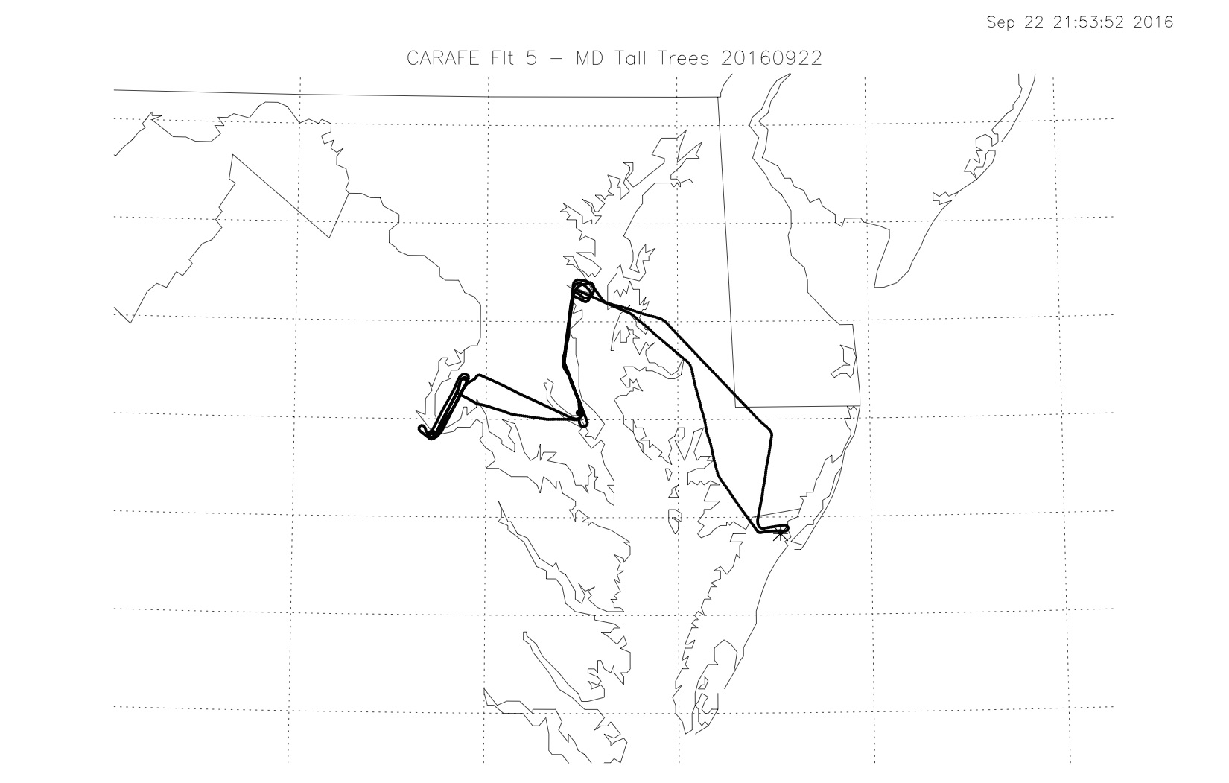

CARAFE Science Flight Report
2016-09-23
Science Flight #6 NJ Pine Barrens Revisited
Pilots: R. Rogers, A. Barringer
Science Crew: R. Kawa, P. Newman, G. Wolfe, J. Digangi
Reporting: R. Kawa

Objectives: Measure GHG, water, and heat fluxes again over the New Jersey Pine Barrens after they received a substantial amount of rainfall (1.5-2 in.) in the past week. Characterize variations of surface flux with forest type, disturbance state, and surface conditions, which should have been much less dry than previous trip. Compare airborne flux distributions with those from Ameriflux tower measurements at Silas Little and Cedar Bridge sites.
http://ameriflux-data.lbl.gov:8080/SitePages/siteInfo.aspx?US-Slt
http://ameriflux-data.lbl.gov:8080/SitePages/siteInfo.aspx?US-Ced

Summary:
Flight was essentially the same as previous. It featured sets of inverted ‘7’ shape flux legs across the Pine Barrens at 1000, near 500 (4) and 1500 ft. A profile to 5000 ft was performed after the legs over the southernmost end of NJ. Legs appeared to pass nearly overhead the Cedar Bridge site and near to the Silas Little sites. Transit flights only took data at high altitudes. Flight duration about 4.4 hours.

Weather was very good for measuring turbulent fluxes from/to the surface. In spite of IFR conditions at WFF and DelMarVa, sky was mostly clear and bright over flux tracks throughout with a thin haze especially evident toward Philadelphia. Boundary layer height near 2000 ft. All legs seemed to have good turbulence including those at 1500 ft. Surface was mostly a wide area of nearly unbroken woods, with some settlements and roads near the middle of the N-S track. Not much agriculture. Forest and intervening wetlands seemed wetter than our previous visit. Comfortable temperatures inside and outside cabin throughout flight at low altitudes.

We had repeated encounters with landfill CH4 near the S end of the flight legs (NJ Mid waypoint). CH4 up to >2.6 ppmv and seemingly filling the whole BL locally (500 and 1500 ft). Sampled at various locations around landfill, up and down wind. Cape May County Mua Secure Landfill (https://ghgdata.epa.gov/ghgp/service/facilityDetail/2014?id=1004200&ds=E&et=undefined&popup=true). We also passed by another landfill on the E-W leg as before but this one had only small CH4 enhancement on downwind side (Ocean County Landfill?). No CH4 enhancement at all coming off extensive marsh grass region along Egg Harbor River. Significant CH4 enhancement (up to 400 ppb) more regionally generally east of NJ-North point that did not seem associated with landfills or general Philly plume. Noted flooded ag fields (cranberries?) as well as cleared forest plots in the area. Area of dead trees also nearby.

Instrument systems and flight procedures performed well. Tried to go to lower altitudes on some legs, but need to maneuver around obstacles and maintain radio contact may have caused more motion variability than worthwhile.

Rawinsonde special sounding at 18Z flown from WFF.

Instruments:
LGR/Picarro/PAR – Used LaRC/AVOCET Picarro from C-130 again. Instrument appeared to run well. Vacuum pumps ran fine at 100% capacity with external cooling fan. LGR instruments and PAR sensor performed well.

DLH – Got good data throughout.

BFVNI – Visible, FLIR, and multispectral (Micasense) cameras acquired images normally.

TAMMS – Good data throughout. Applanix data looks normal.

NASDAT – Data recorded properly. Again noted strange NASDAT-calculated winds in UDP output; to be resolved in post processing.

Event Times (approximate):
14:54 Engine start
14:56 Power switch
15:03 Taxi
15:12:15 Takeoff
15:13 Ascend to 5000 en route to Cape May
15:26 Descend to 1500 ft near NJ mid
15:45 to 18:35 Flux legs at 1000 (1), 500 (4), and 1500 (1) ft
18:35 Ascent to 5000 ft and transit to Wallops
19:05:00 Landing
19:14 Power switch, engines off
19:24 POS-AV stop logging, NASDAT off-on-off
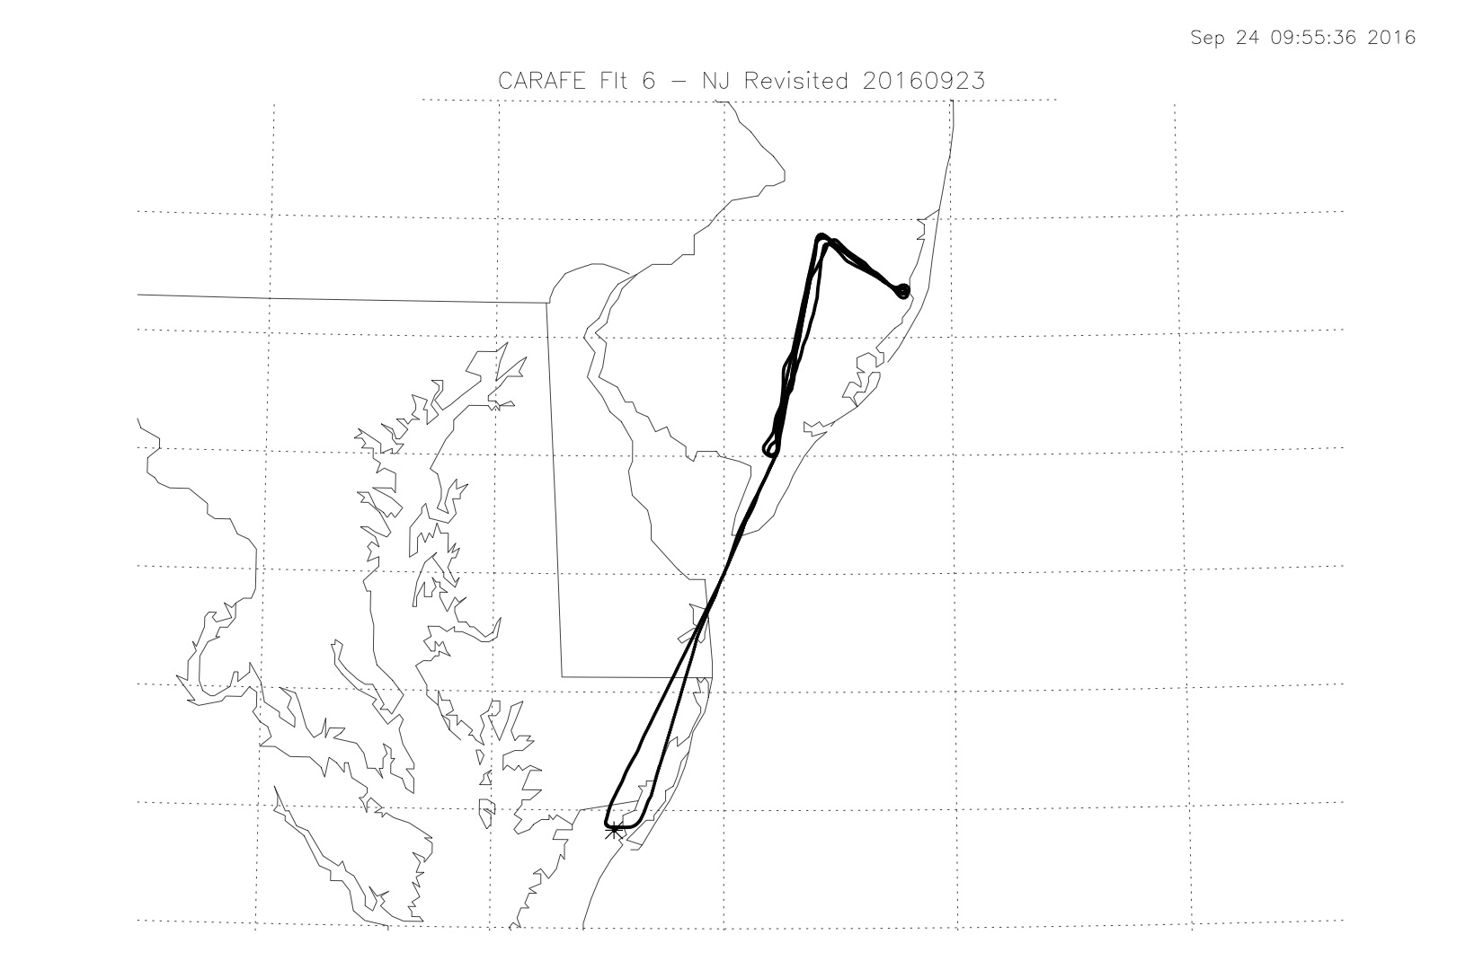

CARAFE Science Flight Report
2016-09-24
Science Flight #7 NC Coastal Forest
Pilots: A. Barringer, R. Rogers
Science Crew: R. Kawa, P. Newman, G. Wolfe, J. Digangi
Reporting: R. Kawa, P. Newman photos

Objectives: Measure GHG, water, and heat fluxes over coastal plain wetland forests in North Carolina/Virginia: Great Dismal Swamp and Alligator River National Wildlife Refuges. Characterize variations of surface flux with forest type, inundation state, and surface conditions especially in search of CH4 flux. Compare airborne flux distributions with those from Ameriflux/NCSU tower measurements at Alligator River site. The latter is one of only a couple sites measuring CH4 flux within range. The Great Dismal Swamp National Wildlife Refuge is the largest intact remnant of a vast habitat that once covered more than one million acres of southeastern Virginia and northeastern North Carolina.
http://ameriflux-data.lbl.gov:8080/SitePages/siteInfo.aspx?US-NC4
https://www2.usgs.gov/climate_landuse/lcs/great_dismal_swamp/GDS_project.asp

Summary:
Flight began with a transit to the Great Dismal Swamp near Virginia Beach, VA at 1500 ft. A set of flux legs was flown N-S in racetrack shape separated by about 3 mi. at 1000, 500, and 300 (1.5) ft. Eastern legs passed over Lake Drummond. A profile to 5000 ft was performed after the legs over the southernmost end en route to Alligator River.

Plane descended to 1500 on transit to Alligator River NW waypoint. N-S legs flux legs were flown at 1500, 1000, and min alt (300 ft) x 4. Racetracks were offset 1.5 and 3 mi from western line. Center track (SE-NE waypoints) passed nearly overhead the US-NC4 flux tower site. A profile to 3500 ft was performed after the legs over the Albemarle Sound en route to WFF. Return transit took data at relatively high altitudes, but final portion at 1000 ft followed a good part of marsh segment planned for Ocean flight. Flight duration about 4.1 hours.

Weather was very good for measuring turbulent fluxes from/to the surface. Sky was mostly clear and bright over flux tracks throughout with a thin haze near BL top. Boundary layer height started at about 1500 ft and grew to about 2000 ft, clearly sloping up to South at Alligator (as forecast by GEOS-5). All legs seemed to have good turbulence including that at 1500 ft, although the latter may have been in entrainment layer. Notably less turbulence over water including Lake D, Sound, and River at all altitudes.

Surface at Dismal was a wide area of nearly unbroken tall, thick forest, with a few fields toward the ends and some swampland near Lake Drummond. Mixed pine and hardwood forest, and intervening wetlands appeared very saturated, although some of the taller trees seem to have shed some leaves. Very interesting variability in CH4 and CO2 associated with Lake and surrounding swamp relative to the woodland. We also had repeated encounters with a landfill just N of the turn at the N end of the track (Tidewater Recycling?). CH4 spike up to 3 ppm.

Surface at Alligator River was a much sparser forest, more variable cover including some dead zones, and with generally more pine. This area was also very wet at surface including flooded farm fields. Dense understory visible in some places. No major features in GHGs. Generally comfortable temperatures inside and outside cabin throughout flight at low altitudes, but getting pretty warm at low altitude late in flight. Finally, no apparent CH4 enhancement coming off extensive salt marsh grass region along final leg into WFF. Light turbulence here.

Instrument systems and flight procedures performed well. Able to go level at lower altitudes on some legs, since fewer obstacles in these areas.

Rawinsonde special sounding at 18Z flown from WFF.

Instruments:
LGR/Picarro/PAR – Used LaRC/AVOCET Picarro from C-130 again. Instrument appeared to run well. Vacuum pumps ran fine at 100% capacity with external cooling fan. LGR instruments and PAR sensor performed well.

DLH – Got good data throughout.

BFVNI – Visible, FLIR, and multispectral (Micasense) cameras acquired images normally.

TAMMS – Good data throughout. Internally recorded Applanix data looks normal. Carl still working output dropouts to NASDAT.

NASDAT – Data recorded properly. NASDAT-calculated winds in UDP output looked good.

Event Times (approximate):
14:33 Engine start
14:35 Power switch
14:42 Taxi
14:47:45 Takeoff
14:50 Ascend to 1500 en route to Norfolk
15:24 Descend to 1000 ft near Dismal NE
15:25 - 16:28 Flux loops at 1000, 500, and 300 (1.5) ft
16:28 – 16:43 Ascent to 5000 ft and transit to Alligator
16:43 – 17:47 Flux legs at 1500, 1000, and 300 ft in racetrack patterns
17:47 Ascend to 3500 ft en route to WFF
18:15 On line over Cobb Bay area at 1000 ft
18:35:00 Landing
18:40 Power switch, engines off
18:50 POS-AV stop logging, NASDAT off-on-off

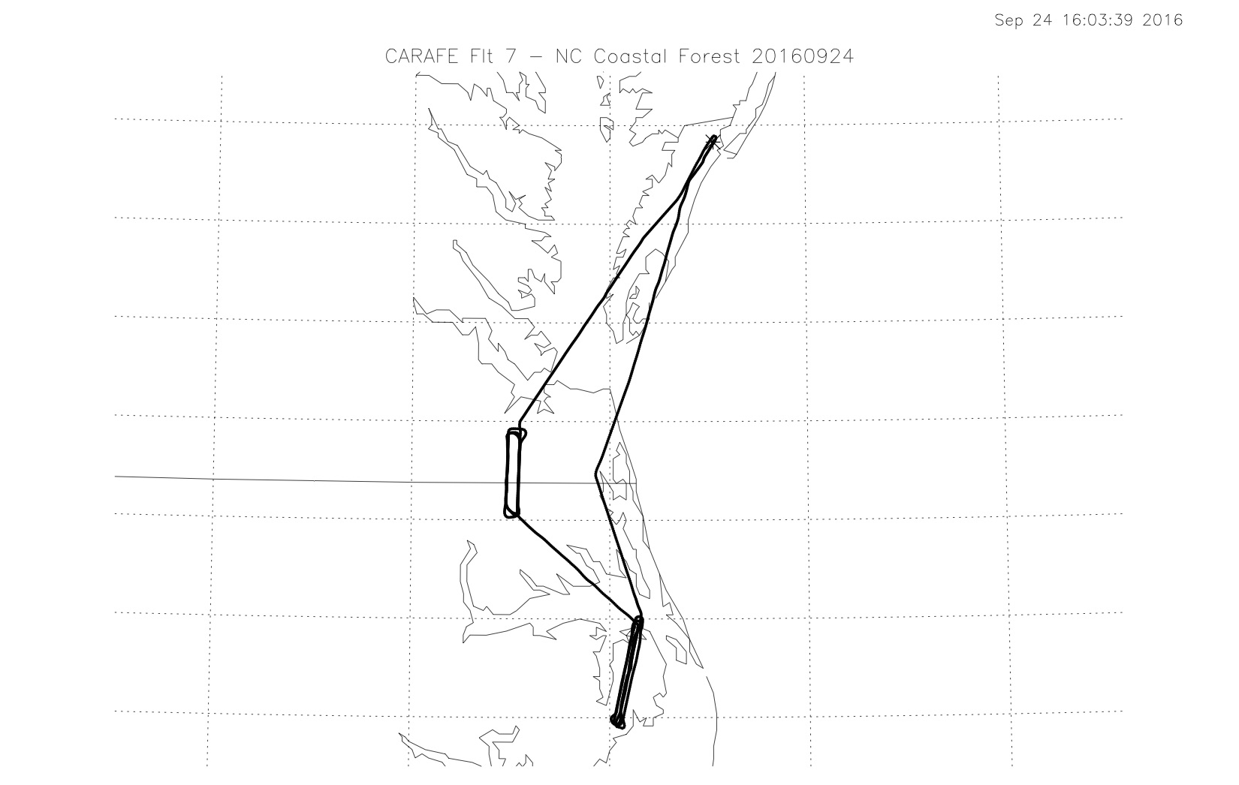

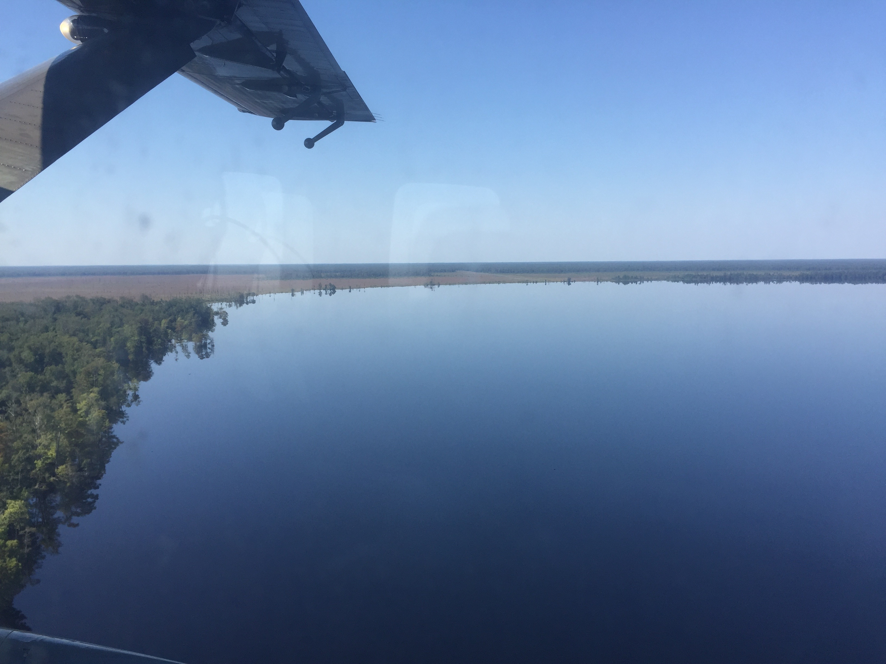

Lake Drummond at Great Dismal Swamp.
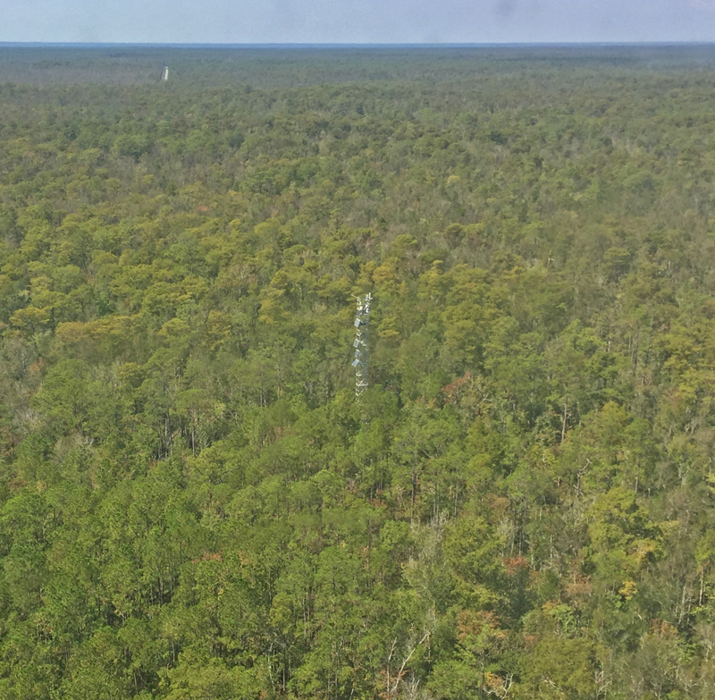

Flux tower US-NC4 at Alligator River Refuge.

CARAFE Science Flight Report
2016-09-26
Science Flight #8 Ocean/Bay Fluxes
Pilots: R. Rogers, A. Barringer
Science Crew: R. Kawa, P. Newman, T. Hanisco, J. Digangi
Reporting: R. Kawa

Objectives: Measure GHG, water, and heat fluxes over open ocean water, coastal areas, and Bay. CH4 fluxes are expected to be 0 over open water so this serves as an instrument null detection test. CO2 fluxes expected to be small with gradients from Bay to near-shore to open water. This may establish CO2 flux detection limit. Leg over tidal wetlands in search of possible CH4 flux. Flight will also explore CH4 enhancement seen over Chester River on the Ag flight. Hypothesis is that CH4 flux may depend on freshness of water, increasing going up river mouths. CO2 flux may also depend on gradients in nutrient loading in the water. Final legs at min alt over Pocomoke for strong CO2 flux verification.

Summary:
Flight began with a 100-mi out and back leg at about 300 ft. over open ocean East of WFF. Three profiles to 5000 ft were performed at the beginning and en route along the legs. Subsequent leg to South from WFF area followed bays inside outermost barrier Islands over shallow water, mud flats, and marsh grass. A long leg ran up the Chesapeake Bay at about 400 ft to East of Baltimore, then a transit over to the Chester River, and down the River mouth back to the Bay. A final Bay run to S connected over the Pocomoke SW waypoint where a pair of flux legs ran over the forest. Profile to 4000 ft and set of air motion calibration maneuvers led back to WFF. Flight duration about 4.4 hours.

Weather was very good to decent for measuring turbulent fluxes from/to the surface. Sky was mostly clear and bright over open ocean tracks throughout with a thin haze near BL top and widely scattered Cu above. Boundary layer height appeared at about 2500 ft but was not strongly capped. Several layers in H2O appeared. Strong CO2 gradient noted. Varying surface wave action but mostly pretty small chop, light winds. All legs seemed to have relatively good turbulence for water, although not as strong as over land. High overcast rolled in over Bay legs thickening over time and to the West. Mild turbulence on Bay legs. Strong turbulence on final Pocomoke legs. Generally smooth at 4000 ft for maneuvers. Comfortably cool in cabin.

No major CH4 enhancement coming off salt marsh regions, Bay water, or Chester this time. Perhaps more variability than open ocean. Caught a CH4 spike near Poplar Island dredging disposal site. Notable CO2 variability over ocean and on final Pocomoke legs. After a couple momentary panic moments initially, instrument systems and flight procedures performed well. Able to go level at lower altitudes on over-water legs, although need to ascend occasionally for comm.

Rawinsonde special sounding at 18Z flown from WFF.

Instruments:
LGR/Picarro/PAR – Used LaRC/AVOCET Picarro from C-130 again. Instrument appeared to run well. Vacuum pumps ran fine at 100% capacity with external cooling fan. LGR instruments and PAR sensor performed well, although LGR CH4 was reluctant to boot up initially.

DLH – Power supply failed at start-up, changed out pre flight. Worked fine after that and got good data throughout.

BFVNI – Visible, FLIR, and multispectral (Micasense) cameras acquired images normally.

TAMMS – Good data throughout. Internally recorded Applanix data looks normal, however, logging restarted preflight in response to media full message. Did not seem to influence recording and disk 47% full. Carl seems to have solved output dropouts to NASDAT.

NASDAT – Data recorded properly. NASDAT-calculated parameters in UDP output looked good.

Event Times (UT approximate):
14:50 Engine start
14:52 Power switch
14:57 Taxi
15:04:35 Takeoff
15:10 Ascend to 5000 ft holding for clearance
15:19 Descend to about 500 ft on line to Open Ocean
15:22 - 16:34 Flux legs out and back over water at about 300 ft
16:36 – 16:53 Flux leg over shallow bay water to S
16:53 Transit to Chesapeake Bay S
17:00 – 17:44 Flux legs up Bay to E Baltimore
17:46 Transit to Chester River
17:48 – 18:01 Leg down Chester to mid Bay
18:04 – 18:19 Leg down Chesapeake toward Pocomoke
18:24 – 18:45 Flux legs over Pocomoke at 400 ft
18:45 Ascend to 4000 ft
18:48 – 19:03 Speed variation, yaw, and pitch maneuvers
19:10:20 Landing
19:17 Power switch, engines off
19:27 POS-AV stop logging, NASDAT off-on-off
